**What is HiLo?**

HiLo is a card game where you play against the dealer. Dealer deals a card and players try to guess the next card. Cards are numbered in order, that is, A is the highest value card and 2 is the lowest, 10 is not included for this game. Bets that can be played consists of:

* **Higher/lower:** players try to guess if the next card is higher or lower than what was dealt by the dealer. Odds change depending on which outcome is more likely.
* **Snap:** players bet on the next card having equal value to the dealer’s card, without considering the suit. For example, if the dealer deals Ace of Spades, players bet on the next card being Ace of anything, Ace of Diamonds, Ace of Hearts, Ace of Spades(repetition is allowed) or Ace of Clubs.
* **No match:** players bet on the next card not being the same card(including suit). For example, if the dealer deals 8 of Spades, players bet on the next card not being 8 of Spades or 8 of Clubs. Logically, probability of this event occurring is highly probable, hence this option was put for miners, rather than regular players.
* **Red/Black:** players bet on the next card having a red suit(diamonds/hearts) or a black suit(spades/clubs).
* **Groups:** There are 3 groups of cards: 2-3-4-5, 6-7-8-9 and J-Q-K-A. Players bet on the next card being in one of these groups. For example, if the next card is Queen of Hearts, players that bet on J-Q-K-A are the winners.

From these options, higher/lower, same card and not the same card options are considered as main bets, red/black and groups are considered as side bets.

**HiLo Probability and House Edge**

|  |  |  |  |  |
| --- | --- | --- | --- | --- |
| **Wager Name** | **Type of Wager** | **Winning Chance** | **Payout** | **House Edge** |
| Hi/Lo/Snap | Main Bet | 8.33% to 91.66% | 1:1.075;1:11.82 | 1.5% |
| No Match | Main Bet | 95.83% | 1:1.028 | 1.5% |
| Red/Black | Side Bet | 50% | 1:1.961 | 1.99% |
| Groups | Side Bet | 33.3% | 1:2.941 | 2.01% |

Max limits for main bets are decided from smart contracts, it is a variable that changes according to the amount of ICX in Iconbet’s treasury. For side bets, there is a 2000 ICX max limit for red/black and 500 for groups.

This game will share 80% of its revenue to TAP holders and 20% of the revenue will go to the developers, Piconbello.

As we have already integrated many games of Iconbet with Tipicon, our release will follow the same pattern. Game is currently ready for public testing, which will soon be announced. Game will be available only on Tipicon initially, then we will release on Iconbet web page with some GUI.

We believe this game can be played with any mindset, regardless of playing for the wins/simply mining TAP. We hope you will find this game enjoyable and thrilling.

Sample user interface for Tipicon can be seen below, which is subject to change, yet be enough to give an overall idea.

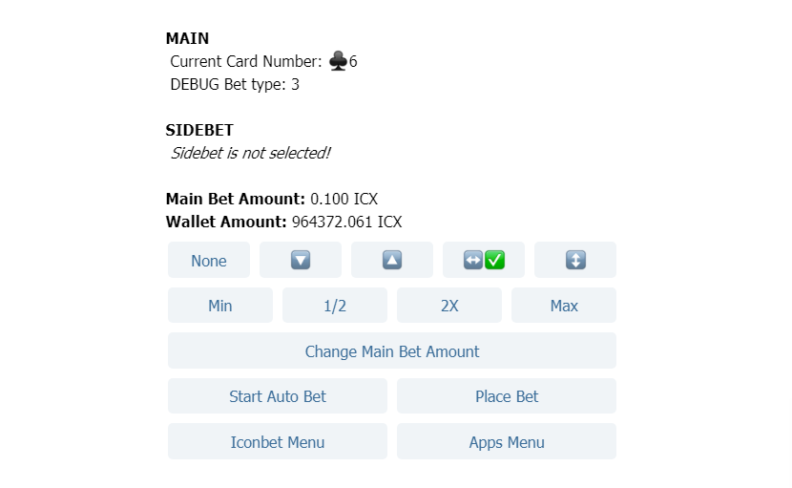

**TAP Holder Voting Instructions**



**Attention ICONbet Community!**

This document gives instructions for submitting votes on ICONbet. When we have a new

vote we will update this post to contain the correct new information, but general process

will continue to be the same.

**ICONbet Voting Process**

Please send your decision (Approve or Reject) in a memo to the below address:

hxc3f2520edabf083dea11fe15cd75d2b62e41b94b

Data Section: “Approve” or “Reject”

**Step 1: Click ICONex browser extension then click “Access My Wallet”**



**Step 2: Click the “Transfer” button**

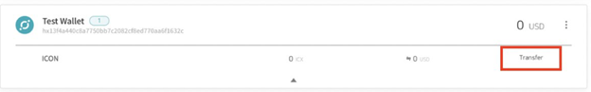

**Step 3: Enter your password then click “Confirm”**

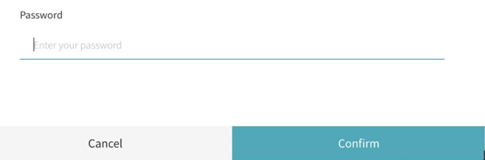

**Step 4: For “Transfer Amount” enter “0”, for receiving address enter**

“hxc3f2520edabf083dea11fe15cd75d2b62e41b94b”, and for “Data” section select

“UTF-8” and enter your vote then click “Transfer”.

